Effect of Point of view shot and how to apply it

Yuki HANAZAWA, Yonguk LEE
Tokyo Polytechnic University
2-9-5 Nakanoku Hontyo
Tokyo, Japan
i1422080@st.t-kougei.ac.jp

Abstract
A point of view shot (also known as POV shot) is a cinematic technique that expresses what a character is looking at. By using this method, it is possible to show a sense of urgency and power. So far it is often used in horror movies and action movies. The number of video works that uses POV shot will increase. So I thought of using POV shot not only for action and horror movies but also for more diverse works. I thought that it might be suitable for the promotion video of the product. Therefore I created a promotion video with the theme of imaginary AR glasses.

Keywords-component; Point of view shot; contents

I. Introduction

Video camera has made great progress in recent decades. One of the benefits is that the camera size became smaller. As a result, range of expression is extended.
Today, there are two main types of images we can see. One is a subjective viewpoint and also it is called POV shot. and another is a third-person perspective shot.
I explored the possibility of movie application while following the history of POV shot.

II. History of POV shot

The history of the movie has begun with Brother Lumiere. The first movie was screened at the basement café in Paris, France in 1895. The story of the movie was about locomotives come into the station and it is filmed by a camera with a fixed point observation. Another movie was a story of a worker who came out from the front gate of the factory after finishing his work of the day. Fixed point ovservation was used in this movie too. This is what is called third-person perspective shot or objective shot
The objective shot is an essence of the image. It records the situation that is visible in front of the camera. On the other hand, subjective shot has appeared in the composition of the image as a method of image expression.
Movie was originally made as an extension of stage dramas. The viewers of stage dramas thought “I want to watch them closer,” and that is the reason why movies were made. Moviemakers filmed movies with tripod because video cameras were big and heavy in early 1900s. There is a scene which is filmed with a POV shot in the horror movie named “Das Kabinett des Doktor Cakigari (1920) [1]”. There is a scene which shows a man who is looking into a house from the window. Then the next cut, you can watch what he is looking at from his perspective (Fig. 1). This is the typicall use of POV shot.
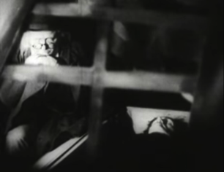
Fig. 1 Footage by “Das Kabinett des Doktor Cakigari (1920)”.

The movie "Napoleon, 1927" produced by French director Abergans [2] consciously incorporated POV shots early in the history of the movie.
Subjective shots are used in a part of the movie, and this technique will spread into subsequent movie works.
Two years after, “the man with Camera” by Russian film director Dziga Vertov [3] was made, and this was the first attempt of the use of dynamic POV shots. Although it is now used in a lot of movies, Vertov installed a camera under the railway line. He then filmed the steam locomotive running from under the railway. The audience were surprised because they felt like they were getting under the railway. Another cut that the POV shot was used is a carriage scene. By shooting a camera from the top of the horse, The viewers can feel like they are riding a horse and seeing around the city.
Vertov composited a POV shot by the relationship between shots and shots.
Sir Alfred Joseph Hitchcock [4] is called a god of suspense movie. He used POV shot a lot in his movies as the expression of a visual Language. After that, POV shot was successfully and positively adopted in movies. As a representive movie, “Rear Window” which was released in 1954 can not be made without POV shots.

“After breaking his leg photographing a racetrack accident, a professional photographer, the adventurous L. B. "Jeff" Jefferies (James Stewart), is confined to a wheelchair in his Greenwich Village apartment to recuperate. His rear window looks out onto a courtyard and several other apartments. During a powerful heat wave, he watches his neighbors, who keep their windows open to stay cool [5]” .

Various incidents were developed from the perspective of the leading character, Jeff. The audience of the movie is able to become Jeff's eyes and feel a strong immersion to the image.
The masterpiece of POV shot expression is the movie, “Psycho” released in 1960. A shot of a murder in the shower room carved out the name of the movie history. This scene effectively used the POV shot to show the view of the girl who is about to get killed. It compelled the viewers to experience the fear of standing in front of the murderer's knife. This technique makes the shot scary like a nightmare.
In video age, movie camera became portable and easier to use because not only the size got smaller, but interface operation got simple. “The Vlair Witch Project (1999) [6]” was a good example of a movie that is made with a video camera and POV shot. This mysterious video is filmed by heavily using POV shots. It is a famous big hit movie which made with a low budget. It proved the possibility of the expression using a portable video camera to the world.
“The Vlair Witch Project” is a famous mockumentary [7] horror movie which used POV shot for most of the scenes.
Camera man holds the video camera and he walks around and runs in this movie. These theatrical effects made it a lot scarier (Fig. 2).

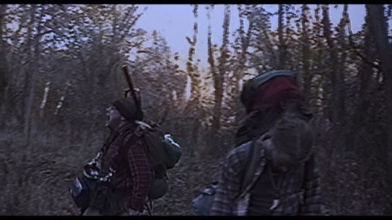
Fig. 2 Footage by “The Vlair Witch Project (1999)”.

In 2016, an action movie “Hardcore Henry (2016)” was made using POV shot through out the movie. They used wearable cameras to shoot (Fig. 3). This movie causes a heavy motion sickness and loses the focus to objects when camera moves so fast because their camera lens has wide field angle. This movie also reminds us a game.
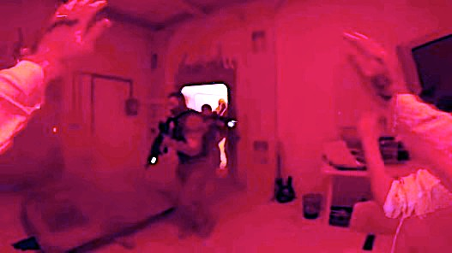
Fig. 3 Footage by “Hardcore Henry (2016)”.

III. Experimental
-a case of Fictional Promotion Video “Re-glass”

A. Equipment and software

Hardware
Camera: SJ4000 (angle of view 120°/ F:2.8)
software
Adobe After Effects CC / Adobe Illustrator CC

B. Pre-production and shooting

First, illustrated scripts were drawn.
Second, Akihabara area in Tokyo was filmed because I wanted to get images of electronic gadgets. There are many electrical stores in Akihabara. I held a camera on my left hand and I moved around with it. It gave a good hand shake for video footages.

C. Post-production
- A sample of the process – scene of the weather search

I wanted to get the image of the background to be as clear and blue as the sky of an urban building town (Fig. 4).

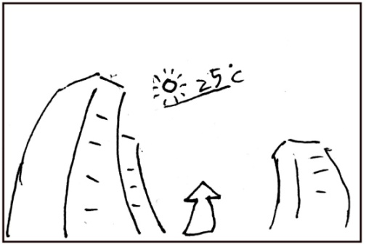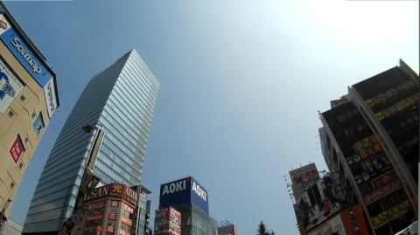
Fig. 4 storyboard and filmed imeage.

The composite image and spcial effect software, Adobe AfterEffects(AE), were used to track the camera motion of the footage image. As a result, the motion of footage image was extracted from the video (Fig. 5).
After that, a graphic image (a text of the temperature) was made in Adobe Illustrator CC. And then the graphic image added and synchronized to the extracted motion of the background image (Fig. 6). Finally, the graphic image and the background image were composited by AE. This final image was used to present the fictional interface of Ri Glass.
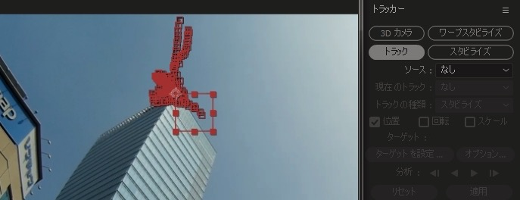
Fig.5 camera tracking still image

This study was applied for the fictional interface of Ri Glass by using the POV shot to make the image more realistic.

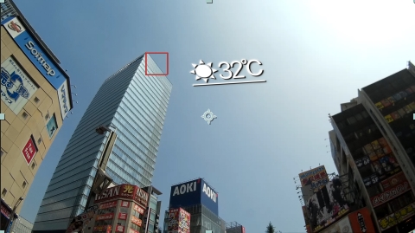
Fig. 6 result of composited image

When I composite them, I paid attentions to lens distortion. The video would look weird if I did not care about distortion.
Then I composited these GUIs to distortion(Fig. 7) (Fig. 8).
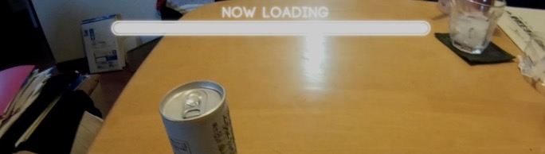
Fig. 7 before lens distortion image

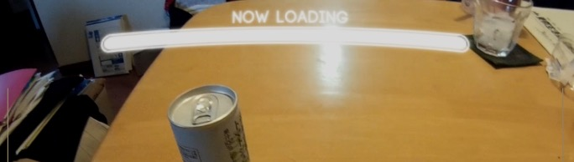
Fig. 8 after lens distortion image

IV. Result
By repeating these processes, a 4 minutes video was made (Fig. 9).
I had some classmates who watched this video, and most of them gave me good feedbacks. Here are some of their thoughts.

“Easy to understand what this thing can do.”
“I want one of the same thing.”

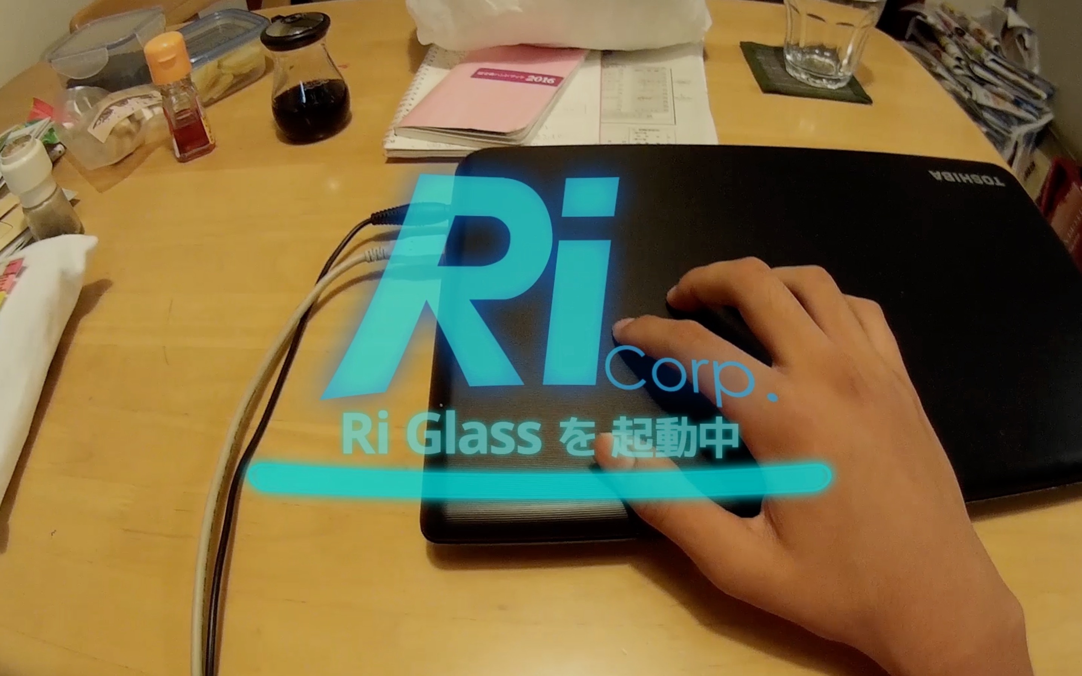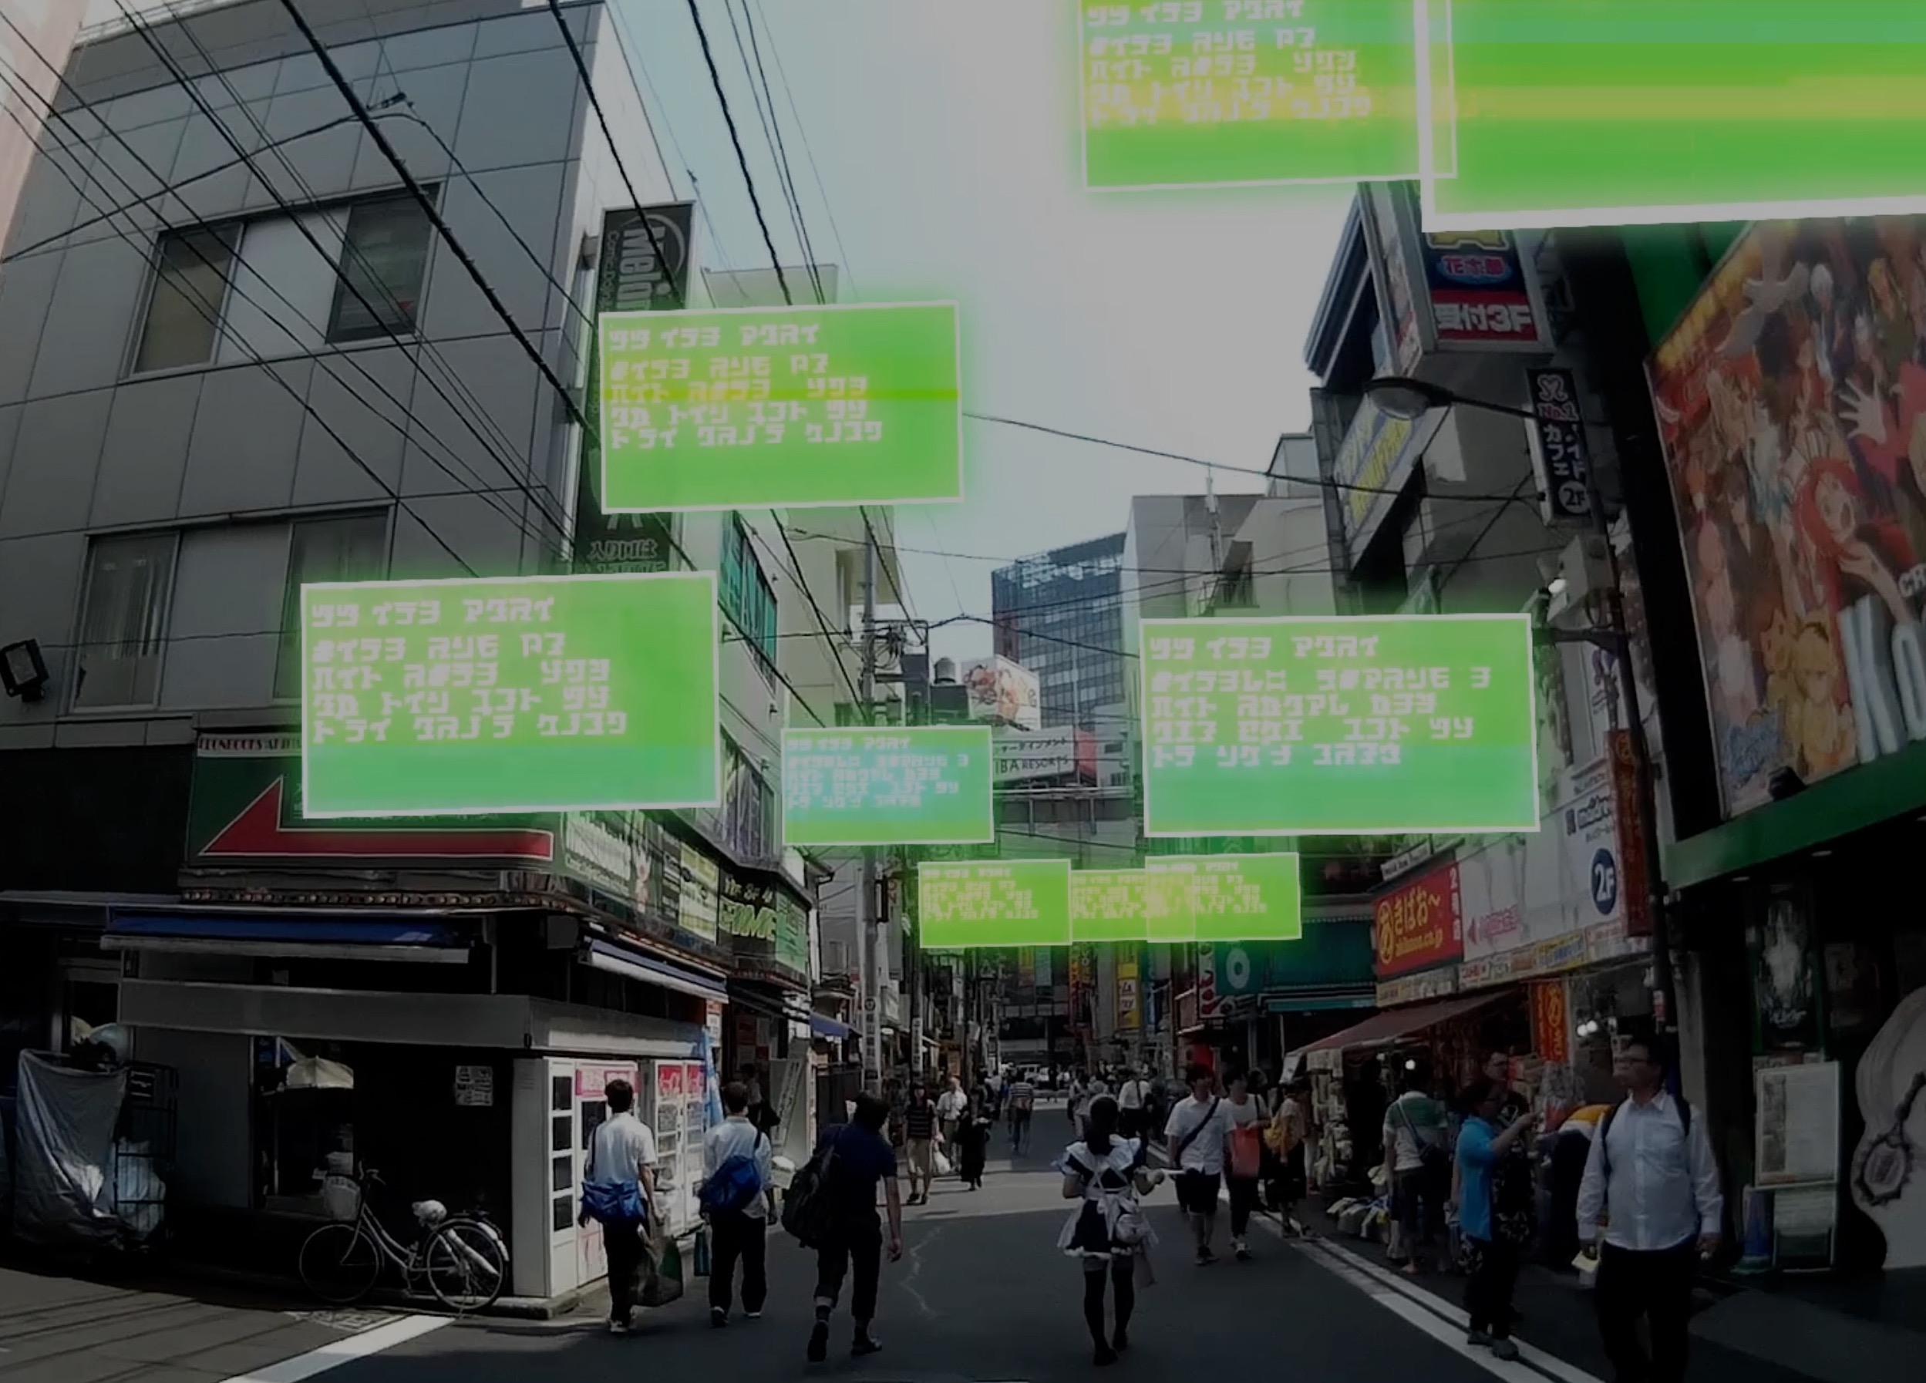
Fig. 9 result of final movie

A. Future of POV shot

Virtual reality(VR) industry is getting quite bigger in past few years. In several years, I think that VR devices will be more popular around the world. In addition to it, advertisers will make commercials for VR device users as they will realize how POV shot is very important to advertise their products. A POV shot is really important thing not only for advertisers but also for the whole video industry.
In other words, no one can ignore a POV shot because it has a lot of possibilities.

V. Conclusion

This study focused on the use of POV shot in film industries. First, It was started by researching the history of POV shot. Second, I made a commercial shot movie as a sample of POV shot application. It was about promoting a fictional interface called Ri Glass. I presented how to use Ri Glass by using POV shot effectively. I would like to consider further extension of POV shot in commercial video expression field.

References

- The Cabinet of Dr. Caligari (German: Das Cabinet des Dr. Caligari) is a 1920 German silent horror film, directed by Robert Wiene and written by Hans Janowitz and Carl Mayer. Considered the quintessential work of German Expressionist cinema.
https://en.wikipedia.org/wiki/The_Cabinet_of_Dr._Caligari (30/10/2016).
- Abel Gance, (October 25, 1889 - November 10, 1981) is a French film director, a screenwriter, an actor. Masters of the silent film world in France.
https://en.wikipedia.org/wiki/Abel_Gance (30/10/2016).
- Dziga Vertov, Дзига Вертов, (2 January 1896 – 12 February 1954) is a film director of the Soviet Union (present Russia)
https://en.wikipedia.org/wiki/Dziga_Vertov (30/10/2016) .
- Sir Alfred Joseph Hitchcock, KBE, (13 August 1899 – 29 April 1980) is a British film director, film producer.
https://en.wikipedia.org/wiki/Alfred_Hitchcock (30/10/2016).
- https://en.wikipedia.org/wiki/Rear_Window (30/10/2016)
- http://www.blairwitch.com/ (30/10/2016).
- A mockumentary (a portmanteau of mock and documentary) or docucomedy is a type of film or television show in which fictional events are presented in documentary style to create a parody.
https://en.wikipedia.org/wiki/Mockumentary (30/10/2016).

