CROSSROADS OF TOPOLOGIES - DC TO DC CONVERTERS

Muhammad Usama Javaid
Institute of Space Technology
Islamabad, Pakistan
usamajavaid14@gmail.com

Syed Afzait Hussain Shah
Institute of Space Technology
Islamabad, Pakistan
syedafzait95@yahoo.com

Abstract

For the conversion of dc to mains ac, a high level of input dc must be supplied, hence comes the application of step up conversion mechanisms. Recently, a lot of dc to dc converters are being implemented whose selection depends mainly upon the low cost, high efficiency, complexity and robustness of the design. The isolated boost converters are becoming much more common for their increased protection of the components and high productivity. The use of high switching frequency and closed-loop feedback mechanism by controlling the PWM plays its role in providing a smooth output and lowers the transformer size. This paper classifies most popular step up conversion topologies according to the desired power rating. Their positives and drawbacks are also discussed in the paper. Finally, a selection among the different topologies is given on the basis of the desired wattage of the system under design.

Keywords: dc-dc converters, output power, efficiency, switching devices
I. Introduction

Dc-based power line distributions and micro grids provide the most efficient solution in the power industry [1], [2], [3]. For reducing the transmission losses and increasing power efficiency in transmitting energy to far off places, high dc to dc converters are needed [1]. To convert dc value into effectively an AC of peak value 220V, it becomes necessary to convert the lower voltages from 12V etc. to up to 311V (usually 330V including losses), which is the RMS value of 220V ac mains cycle [4]. A high intensity discharge (HID) lamp ballast used in automotive headlamps can be considered as an example where there is a need to up convert the 12V to 400V in order to provide the startup voltage during the steady state operation [5]. High voltage converters are also readily used in X-ray imaging and radio frequency generation etc. [6]. The use of MOSFETs and IGBTs are advantageous in terms of reduced size and dynamic responses [7].
PWM is frequently implemented for effectively controlling the output of the dc-dc converters [8], [9]. But there is a requirement of reducing the switching losses of the MOSFETs being used [8].
At present, the size of components has been reduced and hence, the size of dc to dc converters must be minimized too[10]. This is done by raising the frequency of operation and hence reducing the size of the transformer effectively [10].
High efficiency is required in order to effectively convert the voltage levels and this can only be achieved by using the appropriate converter topology [7]. Output filters on the other hand, smooth the output waveforms so that they can be easily implemented by the load attached [11].
This paper discusses the different types of topologies that may be implemented to raise a small voltage input, in the minimum range equal to 12V, to a high output voltage values of 330V dc. The different topologies under discussion include the Flyback arrangement, Forward boost converter, Half- Bridge and the Full-Bridge step up converter [12]. This paper conducts a survey on these different topologies given in various journals and conference papers in terms of the output power and efficiency. The full bridge topology is the highly popular and widely used mechanism in dc-dc converters [4].

II. Component Selection

A. Selection of the switching devices

The use of high switching frequencies is desired to achieve smaller size of the transformers and reduce the cost. Usually, IGBTs are preferred for operating at high frequencies and high voltage levels while at comparatively lower voltage levels and frequencies, power MOSFETs are utilized [13]. For low output voltages, synchronous MOSFETs replace the secondary diodes for rectification [12]. The IGBTs have high switching frequencies, high relative gate impedances than the GTOs and have different voltage ranges for their operation [13]. They also increase power density [14]. Hence, they are replacing the GTOs [15]. To select the switching frequency based on the output power for class E, the following graph can be utilized for the FDN361AN [16].
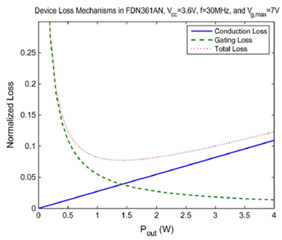
Fig. 1 Normalized device loss for FDN361AN vs Pout
Source: [16]

B. Core Selection
After the selection of the desired switching frequency, the next step is to select the core material for the construction of the transformer [13]. Ferrite cores are most widely used for this operation as they are very small in size and provide high power outputs. The following table1 shows the selection of ferrite cores based on the 20 KHz of switching frequency [13].

TABLE I
COMPARISON OF CORE MATERIALS AT 20 KHZ. 50 KVA.
SOURCE: [13]

Core Material | Bm (Gauss) | Relative Size | Cost $/kg | Relative Cost
Amorphous (260553)  (2605SC) aaaaaaaaa(2714A) | 2,379 | 1.2 | 33 | 67
 | 1,000 | 2.4 | 33 | 128
 | 4,200 | 0.8 | 176 | 232
Ferrite (387)  (H7C4)  (3C80) | 1,600 | 1.3 | 2.2 | 2.9
 | 2,160 | 1.0 | 2.2 | 2.3
 | 1,700 | 1.2 | 2.2 | 2.8
Orthonol (0.051mm)  (0.025mm)  (0.013mm) | 280 | 6.2 | 24 | 241
 | 650 | 3.3 | 33 | 176
 | 950 | 2.5 | 42 | 169
Alloy (0.051mm) | 600 | 3.5 | 24 | 136
Supermalloy(0.051mm)  (0.025mm)  (0.013mm) | 2,000 | 1.4 | 33 | 76
 | 2,500 | 1.2 | 44 | 86
 | 2,900 | 1.1 | 55 | 96
Square Permalloy 80 h (0.051mm)  (0.025mm)  (0.013mm) | 2,400 | 1.2 | 33 | 66
 | 2,000 | 1 4 | 44 | 101
 | 2,400 | 1.2 | 55 | 110
Magnesi | Low | large
Supermendur | low | large
The cores can also be chosen depending on output needs as given by Magnetics core selection tables [17].

III. Proposed Topologies

There are a number of topologies like non-isolated topologies discussed in [5], [18], step down topologies by considering the buck-flyback topology given in [19] and also some multiple input dc-dc converter topologies in [20] and [21] and most modern of them being the digitally controlled models as described in [22]. However, we are interested in the basic converter configurations as discussed later.

A. Flyback Converter

The flyback arrangement is elaborated in the Fig. 2 [23]. It works on the principle that when the transistor conducts, the diode D1 is reverse biased [23] and no energy flows towards load [24], rather is stored in transformer’s primary windings [23].
When the transistor is turned off, the diode forward biases due the referred magnetizing current to the secondary winding [24]. This stored power is then fed to the load [23]. The flyback arrangement can be made bidirectional by connecting switches at the primary as well as the secondary [25]. The gain of the flyback arrangement [23] is given as:

$M\left(D\right)=\frac{V}{Vg}=n\frac{D}{(1-D)}$ (1)
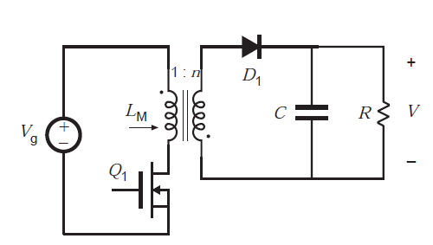
Fig. 2 Basic Flyback Arrangement
Source: [23]

- Merits & Demerits

The flyback arrangement has been used in power supplies of the televisions and also has been extensively used in the systems of lower wattage (50-100W) [23]. The major positive of using this configuration is the least number of components that are being used in its mechanism and also the simplicity that it provides in the control mechanism [24] [23].

B. Forward Converter

Its basic circuitry is shown by the Fig. 3. An extension to the flyback converter is the forward converter [26]. Here, the increase in efficiency is done by returning the energy stored in transformer to the source [24]. When the transistor is switched on, the output diode D1 is forward biased and the power transfers through filter and finally to load [24]. Hence, power is not stored in transformer [26].
On switching the transistor off, the reverse polarity of the transformer causes the diode D1 to be reverse biased and the other two diodes D2 and D3 are forward biased for transferring the power to load through the inductor L [24].
For same turns ratio, the duty cycle is reduced to half (0.5) [23] hence limiting to the range D<=0.5 [23] and in general is given by:
$D≤\frac{1}{1+\frac{Np}{Nr}}$ (2)
The output voltage [27] becomes:
$V_{out}=V_{in}×\frac{n_{2}}{n_{1}}×T_{on}×f$(3)
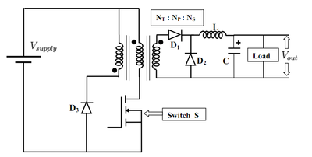
Fig. 3 Basic Forward Arrangement
Source: [28]

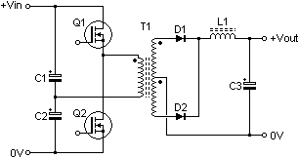
Fig. 4 Basic Half Bridge Arrangement
Source: [29]

- Merits & Demerits
As the transformer does not store energy in this case, therefore, there is a requirement of a minimum load that should always be present at the output so as to compensate a very high output voltage that can accommodate at the capacitor [24]. This topology is used for medium power ranges of below 200W.

C. Half-Bridge Converter
Fig. 4 shows the basic arrangement of half bridge converters [29]. This topology matches the mechanism of two forward converters joined in cascaded form[24]. Capacitors play the role of maintaining the voltage across the primary [30] as the half of the input voltage [24].
There are a total of four modes of operation. Mode1 corresponds to when Q1 is on and Q2 is off, Mode2 corresponds to when both Q1 and Q2 are off, Mode3 when Q1 is off and Q2 is on and finally, Mode4 corresponds to when again both the transistors are off [24]. During the Mode1, the diode D1 conducts only and hence the half “Vp” is transferred to secondary and finally to output [24]. During Mode3, the diode D2 conducts only and hence the half of negative Vp goes to secondary and finally to output[24]. During Modes2 and 4, the stored magnetizing current flows through output diodes [24].
The output [31] becomes:

$Vo=Vs(\frac{Ns}{Np})D$ (4)

- Merits & Demerits
In this case, the duty cycle cannot exceed 50% and this topology is used in power ranges of up to 400W [24]. In comparison to forward converter, output wattage of half bridge configuration is twice for the same switching devices and ferrite cores because of half primary voltage applied at the MOSFETs effectively [24]. But due to more complexity, the forward or flyback arrangements are preferred for power applications of less than 200W [24]. Also, the half bridge effectively utilises only half of the input ac cycle.

D.Full-Bridge Converter

The final and the most efficient topology under implementation these days is the full-bridge configuration of the dc-dc converters. Fig.5 shows the basic arrangement of this famous topology [24]. Just like the half bridge converter, full bridge configuration also has four modes of operation. The Mode1 corresponds to when 1st and 4th switches are on and 2nd and 3rd ones are in off state, Mode2 corresponds to when each switch is off, Mode3 when 1st and 4th are off and 2nd and 3rd are on and finally, Mode4 corresponds to when again all of the transistors are off [24]. The two pairs of transistors Q1, Q4 and Q2, Q3 are alternatively driven simultaneously [27].
The voltage after being stepped up by the transformer’s turns ratio is then converted to pure dc by rectification and filteration[24]. Fig. 6 shows the typical waveforms of the full-bridge dc-dc configuration.
During the Mode1, voltage is given by VgDTs. And during the mode3, the total voltage is equal to –VgDTs. Hence the overall applied volt-seconds to the primary equals zero [23]. The output voltage [31] is thus given by:

$Vo=2Vs\left(\frac{Ns}{Np}\right)D$ (5)

The duty cycle is given by [32]:

$D=\frac{ton}{Ts}$ (6)

- Merits & Demerits

This topology is useful for very high output power requirement of above 500W and has the most efficient use of the magnetization ferrite core and the MOSFETs being used [23]. The full-bridge uses four MOSFETs as compared to the half bridge configuration and also has twice the output power of the half bridge, where half bridge only utilized half of the effective ac cycle [24]. However, in terms of cost and complexity, full bridge is the most expensive and the complex one to manufacture. The tapped inductor can be used in the output that solves the problem of conduction losses during the freewheeling period [33].
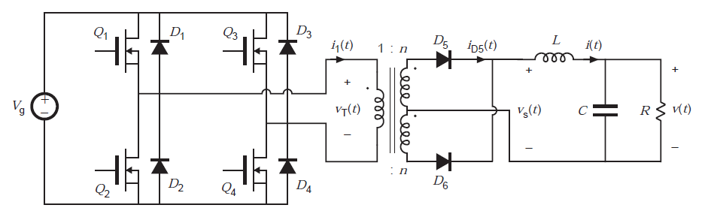
Fig.5 Basic Full-Bridge Arrangement
Source: [23]
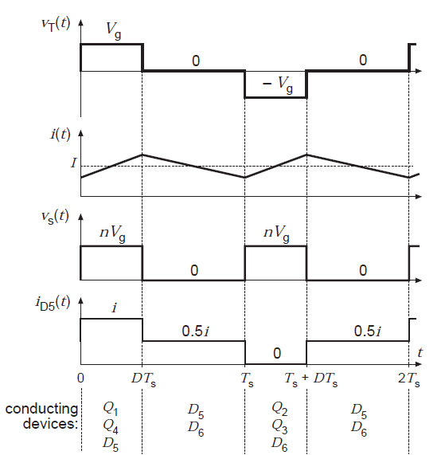
Fig.6 Typical waveforms of Full-Bridge Arrangement
Source: [23]

IV. Conclusion

The paper reviewed selection of components and surveyed different topologies that help in prototyping the dc- dc step up converters. We studied the basic mechanisms of the most widely used topologies and discussed their merits and demerits. In a nutshell, we come to the conclusion that for low power demands and low cost, we can easily choose the flyback or the forward converters in designing our system. However, this selection comes with greater simplicity but very low efficiency at the output. For higher wattage systems, more complex designs like half bridge or the full bridge configurations must be used. Although these configurations are comparatively expensive and hard to build, these converters provide much greater efficiency, control and effective utilization of the components.

References

[1] Li, W. et al. 2015. Modular Multilevel DC/DC Converters With Phase-Shift Control Scheme for High-Voltage DC-Based Systems. IEEE Transactions on Power Electronics. 30, 1 (2015), 99-107.
- Mishima, T. and Nakaoka, M. 2009. A Novel High-Frequency Transformer-Linked Soft-Switching Half-Bridge DC-DC Converter With Constant-Frequency Asymmetrical PWM Scheme. Industrial Electronics, IEEE Transactions on. 56, 8 (2009), 2961 - 2969.
- Das, P. and Moschopoulos, G. 2008. An Integrated Dc-dc Power Converter For Use In Distributed Generation Power Systems. Telecommunications Energy Conference, 2008. INTELEC 2008. IEEE 30th International (2008).
- Tofoli, F. et al. 2015. Survey on non-isolated high-voltage step-up dcâ€“dc topologies based on the boost converter. IET Power Electronics. 8, 10 (2015), 2044-2057.
- Qun Zhao, and Lee, F. 2003. High-efficiency, high step-up DC-DC converters. IEEE Transactions on Power Electronics. 18, 1 (2003), 65-73.
- Chen, R. et al. 2008. Study and Implementation of a Current-Fed Full-Bridge Boost DC-DC Converter With Zero-Current Switching for High-Voltage Applications. IEEE Journals & Magazines. (2008), 1218 - 1226.
- Carr, J. et al. 2009. A Three-Level Full-Bridge Zero-Voltage Zero-Current Switching Converter With a Simplified Switching Scheme. IEEE Transactions on Power Electronics. 24, 2 (2009), 329-338.
- Mishima, T. et al. 2013. Analysis, Design, and Performance Evaluations of an Edge-Resonant Switched Capacitor Cell-Assisted Soft-Switching PWM Boost DC-DC Converter and Its Interleaved Topology. Power Electronics, IEEE Transactions on. 28, 7 (2013), 3363 - 3378.
- Chen, J. and Ngo, K. 2001. Alternate forms of the PWM switch model in discontinuous conduction mode [DC-DC converters]. IEEE Trans. Aerosp. Electron. Syst.. 37, 2 (2001), 754-758.
- Liu, Y. and Sen, P. 1996. New Class-E DC-DC converter topologies with constant switching frequency. IEEE Transactions on Industry Applications. 32, 4 (1996), 961-969
- Mitchell, D. 1999. Power line filter design considerations for DC-DC converters. IEEE Industry Applications Magazine. 5, 6 (1999), 16-26
- Ye, Z. 2013. Dual Half-Bridge DC-DC Converter With Wide-Range ZVS and Zero Circulating Current. Power Electronics, IEEE Transactions on. 28, 7 (2013), 3276 - 3286.
- Steigerwald, R. et al. 1996. A comparison of high-power DC-DC soft-switched converter topologies. IEEE Transactions on Industry Applications. 32, 5 (1996), 1139-1145.
- Sayed, K. et al. 2010. New high-frequency linked half-bridge soft-switching PWM DC-DC converter with input DC rail side active edge resonant snubbers. IET Power Electronics. 3, 5 (2010), 774.
- Zhou, Y. et al. Comparison Of Dc-dc Converter Topologies For Offshore Wind-farm Application. Power Electronics, Machines and Drives (PEMD 2012) (Bristol), 1 - 6.
- Warren, J. et al. 2008. Transistor Selection and Design of a VHF DC-DC Power Converter. IEEE Transactions on Power Electronics. 23, 1 (2008), 27-37.
- Ferrite Cores, MPP Cores, Tape Wound Cores, Sendust Cores| MagneticsÂ®:2015http://www.mag-inc.com.Access:2015-12-01
- A., N. et al. 2013. Comparison of High Gain Topologies Of Nonisolated Dc-dc Converters For Fuel Cell Application. IEEE Conference Publications (Chennai, 2013), 367 - 372.
- Birca-Galateanu, S. 1988. Buck-flyback DC-DC converter. IEEE Trans. Aerosp. Electron. Syst.. 24, 6 (1988), 800-807.
- H. Choung, S. and Kwasinski, A. 2008. Multiple-Input DC-DC Converter Topologies Comparison. IEEE (2008).
- Ibanez, F. et al. 2014. High-Current Rectifier Topology Applied to a 4-kW Bidirectional DCâ€“DC Converter. Industry Applications, IEEE Transactions on. 50, 1 (2014), 68 - 77.
- Corradini, L. and Mattavelli, P. 2008. Modeling of Multisampled Pulse Width Modulators for Digitally Controlled DC-“DC Converters. IEEE Power Electronics Society. 23, 4 (2008), 1839 - 1847.
- Webster, J. 1999. Wiley encyclopedia of electrical and electronics engineering. John Wiley.
- Rashid, M. 1993. Power electronics. Prentice Hall.
- Gunasekaran, D. and Umanand, L. 2012. Integrated magnetics based multi-port bidirectional DC-DC converter topology for discontinuous-mode operation. IET Power Electronics. 5, 7 (2012), 935-944.
- Woias, P. et al. 2013. A low-voltage boost converter using a forward converter with integrated Meissner oscillator. J. Phys.: Conf. Ser.. 476, (2013), 012081.
- SwitchModePowerSupplies:2015.http://kralciplak.tripod.com/Electronic/smps.html.Access:2015- 11- 29
- WikiMedia:2015.https://upload.wikimedia.org/wikipedia/en/thumb/7/7d/Schematic_of_a_forward_converter.png/400px-Schematic_of_a_forward_converter.png. Accessed: 2015- 11- 29.
- KralciplakTripod:2015.http://kralciplak.tripod.com/Electronic/halfbrdg.gif. Accessed: 2015- 11- 29.
- Power Supply Technology - Half-Bridge DC/DC Converters| MouserElectronics:2015.http://eu.mouser.com/applications/power-supply-topology-half/. Accessed: 2015- 11- 29.
- Daniel W. Hart. Power Electronics by daniel hart.
- Fan, S. et al. 2014. Current output hard-switched full-bridge DC/DC converter for wind energy conversion systems. IET Renewable Power Generation. 8, 7 (2014), 749-756.
- Moisseev, S. et al. 2003. Full-bridge soft-switching phase-shifted PWM DC-DC power converter using tapped inductor filter. Electron. Lett.. 39, 12 (2003), 924.

