Color Therapy: Estimating Hidden Relationship between Colors and Human Emotions

Yaohui Yu, Eunjeong Ko, and Eun Yi Kim

Visual Information Processing Laboratory, Dept. of Internet and Multimedia Engineering, Konkuk University
1204 New Millennium Building, Konkuk University, 120 Neungdong-ro, Gwangjin-gu, 05029
Seoul, South Korea
{ yuyaohui, rritty33, eykim }@konkuk.ac.kr

Abstract

Color therapy has been employed to various industrial domains such as interior, textile, interface design so on. Conventional color therapy recommends colors defined on psychological knowledge and market surveys. These approaches can provide somewhat limited colors to the user; the colors have similar hue or tone. Therefore, we propose a novel color therapy that automatically estimate hidden relationship between colors and human emotions by probabilistic latent semantic analysis, and then recommends color combinations and paintings to the user according to their emotional state. For this, we crawl emotional landscape images from web and social network services and build ground truth by user study. We extract color compositions from the images and quantize them into occurrence vector. Finally, the probabilistic latent semantic analysis estimates relationship between emotions and color compositions, which is called as scale. The learnt scale is used to recommend the proper colors to the user. To evaluate the proposed method, we first measure the accuracy of predicting emotions hidden in image, and then analyze the recommended results with comparing the conventional color therapy.

Keywords-Color therapy; Probabilistic Latent Semantic Analysis; Emotion recognition; Artworks recommendation.

I. Introduction

Color therapy (Color hearing) is a type of holistic healing that uses the visible spectrum of light and color to affect a person’s mood and mental health. Some colors are proved to have an effect on people who have brain disorders or people have emotional troubles [1, 2, 3]. For example, blue can have a calming effect, whereas red may have the opposite effect. Green is another color that can be used to relax people who are emotionally unbalanced. Yello can be used to help invigorate people who may be suffering from depression and improve self-confidence. According to this, color therapy has been slowly used in mental health treatment. In addition, Color therapy has been employed to various industrial domains such as interior, textile, interface design so on. Conventional color therapy recommends colors defined on psychological knowledge and market surveys. These approaches can provide somewhat limited colors to the user; the colors have similar hue or tone.
Many studies have enabled computer to recognize human’s emotion or mood. In [4], they proposed and validated a novel methodology to automatically recognize facial emotions, which using a real-time face tracker output to define and extract two types of features, then use the features to train a machine learning classifier. A deep Convolutional Neural Network based approach was proposed to classify the emotions expressed by the primary human subject in static images extracted from movies [5]. A system using Support Vector Machines for classifying six basic emotions and neutral expression along with checking mouth status was proposed in [6].
Therefore, we propose a novel color therapy that automatically estimate hidden relationship between colors and human emotions by probabilistic latent semantic analysis, and then recommends color combinations and paintings to the user according to their emotional state. For this, we crawl emotional landscape images from web and social network services and build ground truth by user study. We extract color compositions from the images and quantize them into occurrence vector. Finally, the probabilistic latent semantic analysis estimates relationship between emotions and color compositions, which is called as scale. The learnt scale is used to recommend the proper colors to the user.
To evaluate the proposed method, we first measure the accuracy of predicting emotions hidden in image, and then analyze the recommended results with comparing the conventional color therapy.

II. Overview of the Proposed Method

The goal of the proposed method is to automatically estimate relationship between colors and human emotions, and then recommend the proper colors based on learnt the relationship according to his/her emotional state.
In order to the proper colors to the user, we first analyzes conventional color therapy based on psychological study. The recommended color has effects of enhancing good emotions such as ‘happy’ or relaxing negative emotions such as ‘angry’, ‘surprise’ and ‘fear’. The color for same emotion usually are similar hue and tone each other. It is difficult to apply same therapy to various domain. Therefore, we map color and its function based on the psychological knowledge into Kobayashi’s affective model [12]. The Kobayashi’s model contain 180 affective words and consists of these words and color features that can be extended from one color to three or five combitations. For mapping them, we select the relevant colors and words in the Kobayashi’s model. Table 1 shows the mapped Kobayashi’s affects according to human emotions. Based on these affects, we estimates the relationship between the color features and human emotions.
The proposed method consists of offline phase and online phase. In offline phase, it estimates correlation between human emotions and color features, which is called as ‘scale’. Online phase recognizes human’s emotional state through real-time facial expression recognition, and then suggests colors and artworks to provide therapy effects. Figure 1 shows the overview of the proposed method.

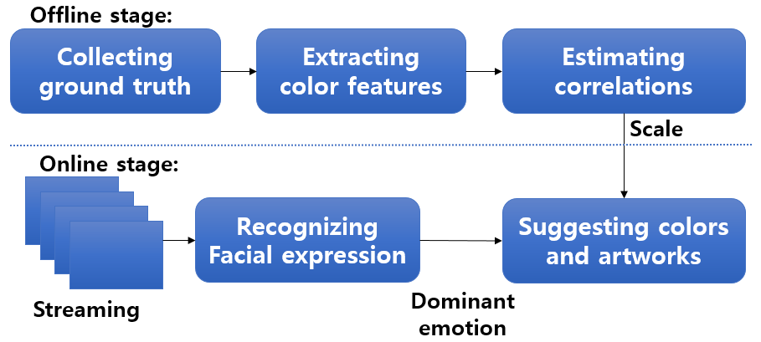
Figure 1. Overview of the proposed method.

In offline stage, it first collect images from web and social network services and build ground truth using 15 Kobayashi’s affective words. Second, it extract color compositions as one of color features from the ground truth, the finally learns probabilistic latent semantic analysis in order to estimate hidden contexts between such color feature and Kobayashi’s affective words via probabilistic latent semantic analysis (pLSA).
In online stage, given streaming from web camera, it first detects user’s facial region via adaboost algorithm, and recognizes user’s emotional state using convolutional neural network (CNN), and then finally suggests the proper color compositions and artworks according to the user’s dominant emotion.

III. Correlation Analysis via pLSA

Generally color features were used to represent global characteristics such as color histogram, average color and so on. These features could not capture local and spatial information. Therefore, we investigate color composition extraction based on Kobayashi’s color image scale (CIS) [4], which is composed of 1,170 triplet color compositions (CCs). Among 1,170 CCs, we filtered color compositions rarely occurred in images; as such a color dictionary consists of 592 visual words.
Algorithm 1 shows the process to extract the color compositions (CCs) from images. First, the images are segmented using quantization and mean-shift clustering. As extracting the CCs from all regions requires high computational costs, we only consider the seed regions with high importance values (3rd line to 7th line in algorithm 1). For every seed region, the triplet CCs are defined by combining its own color and the colors of its neighboring regions. All extracted CCs are compared with 592 Kobayashi’s CCs and are matched to the CCs with high similarity scores. Each element of which represent the occurrence of a certain color composition in the image.

Algorithm 1. Color composition extraction.
Input |  | $I$ : Input image  $D_{c}$ : visual dictionary for color defined by Kobayashi’s CIS
Output |  | $λ_{i}$ : Occurrence vector for color feature
1 | Perform color quantization to transpose 2²⁴ RGB colors to 130 colors
2 | Segment the image into regions using mean-shift clustering
3 | For each region $R_{j}$,
4 | Calculate the normalized area $A\left(R_{j}\right)=\left(\frac{area}{width×height}\right)$
5 | Calculate the Gaussian distance between the centroid d of the  current region and the centroid μ of the image  $$G\left(R_{j}\right)=G_{d}\left(μ, Σ\right)=\frac{1}{2π\left|Σ\right|}e^{-\frac{1}{2}{\left(d-μ\right)}^{T}Σ^{-1}(d-μ)}$$
6 | Calculate the significance value $ϕ\left(R_{j}\right)=A(R_{j})×G(R_{j})$
7 | Perform sorting by significance value $ϕ\left(∙\right)$ and select top M regions
8  9  10  11 | For each region in M,  Generate color compositions by combining three colors of  current region and its two adjacency region  For each color composition $λ_{i,a}$ of a region m,  Find a nearest color composition from the dictionary $D_{c}$, $ξ_{k}$
12 | Calculate the weight using $ϕ\left(R_{M}\right) ×similarity (λ_{i,a},ξ_{k})$
13 | Add the weight to the k-th element in vector $λ_{i}$
14 | Normalize the occurrence vector $λ_{i}$
15 | Terminate.

Correlation analysis via pLSA learning: To learn the pLSA model, a term-document matrix should be computed as a prerequisite. The $n(d_{i}, w_{j})$ means the number of the visual feature $w_{j}$ occurred in the image $d_{i}$. The occurrence vector ($n\left(d_{i}, w_{1}\right), n\left(d_{i}, w_{2}\right), …, n(d_{i}, w_{j})$) of $d_{i}$ is normalized using L1-norm. Thus, the pLSA model is trained by an expectation maximization (EM) algorithm. We train the pLSA to estimate$P(w_{j}|z_{k})$ the probability of a sentiment given the current image as the scale and$P\left(z_{k} | d_{i}\right)$, the probability of a sentiment given the current image as the ground truth.
E-step: The probabilities of sentiments given the observations $P\left(z_{k}|d_{i}, w_{j}\right)$ are computed from the previous estimate of the model parameters (randomly initialized).
$$P\left(z_{k}|d_{i}, w_{j}\right)∝ \frac{P(z_{k}|d_{i})P\left(w_{j} | z_{k}\right)}{\sum_{z∈Z}{P\left(z_{z} | d_{i}\right)P(w_{j}|z_{z})}}$$
M-step: The parameter $P(w_{j}|z_{k})$ are updated with the new expected values$P\left(z_{k}|d_{i}, w_{j}\right)$.
$$P\left(w_{j} | z_{k}\right)∝ \frac{\sum_{j∈W}{n\left(d_{i}, w_{j}\right)P\left(z_{k}|d_{i}, w_{j}\right)}}{\sum_{j∈W}{\sum_{i∈D}{n\left(d_{i}, w_{j}\right)P\left(z_{k}|d_{i}, w_{j}\right)}}}$$
$$P\left(z_{k} | d_{i}\right)∝ \frac{\sum_{j∈W}{n\left(d_{i}, w_{j}\right)P\left(z_{k}|d_{i}, w_{j}\right)}}{n\left(d_{i}\right)}$$
Figure 2 shows scales generated by pLSA learning, where x-coordinate is the visual features from 592 CCs and y-coordinate is Kobayashi’s sentiment, respectively. The brighter cells mean that the visual features have the high relationship with the corresponding to the affects.

Table 1. Recommended color information according to emotion.
Emotion | Color | Color Effects | Mapped affects | Color compositions learnt by pLSA
Anger |  | Broad mind, Liberation | Cool, modern
Disgust |  | Peace, Stability, Calmness | Cool, natural
Fear |  | Reinforcement, Bright, Harmony | Pretty, Romantic
Happy |  | Comfort, Nature, Young | Pure, Romantic
Sadness |  | Recovery, Bounce, Warm | Dynamic, Gorgeous
Surprise |  | Stability, Relax, Calmness | Cool, quiet
Neutral |  | Wisdom, Aesthetic | Natural

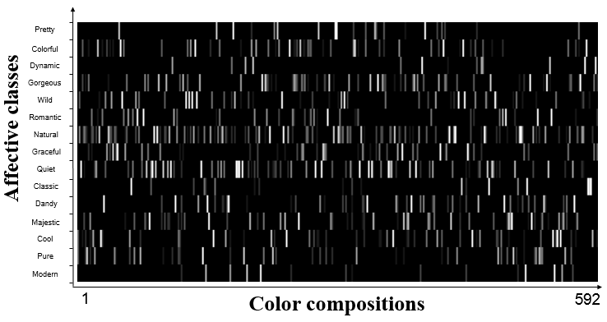
Figure 2. Visualization result of the learnt scale.

IV. Real-time Emotion Recognition

It consists of face detection using Adaboost algorithm in real time and facial expression analysis with convolutional neural network.
A. Face Detection via Adaboost Algorithm
For the past two decades, face detection has always been an active research area in the vision community. Face detection should satisfy following two requirements: First, it should be robust to time-varying illumination and cluttered environments. Second, it should be fast enough to supply real-time processing. Viola and Jones [7] proposed an efficient algorithm which is Adaboost algorithm.
B. CNN-based Facial Expression Recognition
We recognize emotions after detecting the user’s facial region. Ekman’s emotion model was built on facial expression, it has been widely used in understanding human’s emotions. We use Ekman’s 6 basic emotions [8]: {anger, disgust, fear, happy, sad and surprise} and neutral to represent user’s emotion in this work. We apply CNN to find the highly associated features from facial regoin with users’ emotions.
We used a trained CNN model proposed by [9], they fine-tune pre-trained object classification networks on a large face recognition dataset which is CASIA WebFace dataset [10]. Figure 3 shows architure of the CNN model used in this work. Fine-tuning is a transfer learning scheme, which is not only replace and retrain the classifier on top of the convolutional network on new dataset, but also fine-tune the weights of the pre-tained network. Since receiving an efficient CNN model, it needs a large number of data and complex computation. It is easy to achieve this by using fine-tuning. The experiment was implemented using Caffe, a deep learning framework created by Jia et al [11].
Figure 4 shows the result of the emotion recognition. Left images are face detection results and right images represent the distribution of the predicted emotions, respectively.
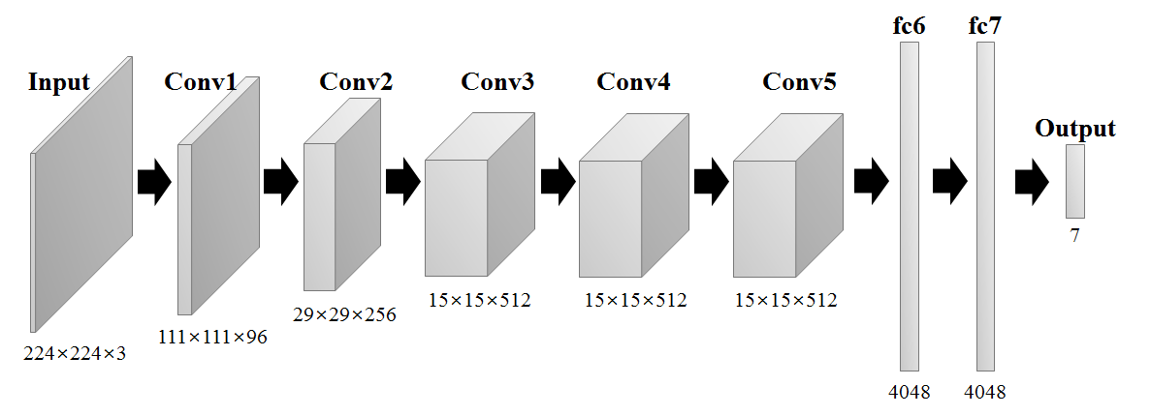
Figure 3 Archtecture of CNN model used in the proposed model.
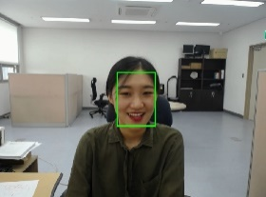 | 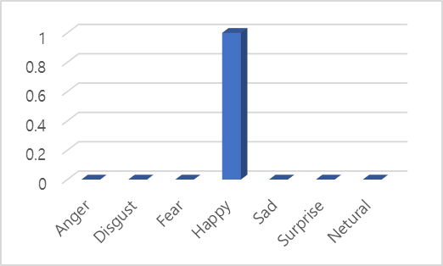
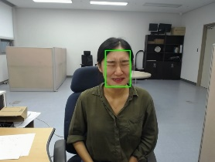 | 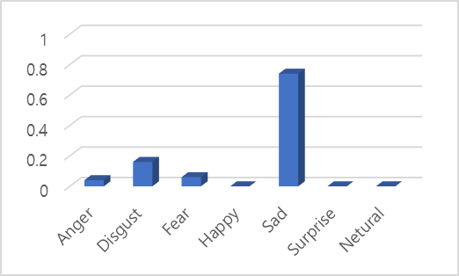
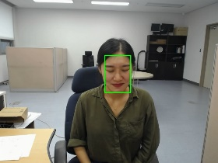 | 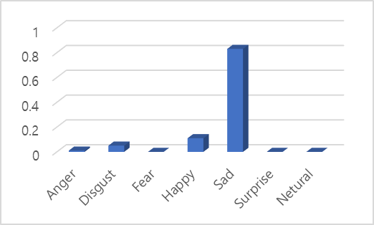
(a) | (b)
Figure 4 Example of emotion recognition results.

V. Color Therapy

In this paper, we suggest colors and artworks according to user’s emotional state. For recommending colors, the proposed system recommends the highly ranked color compositions as showin in Table 1.
Painting recommendation is applied after recognize user’s emotion. We collect paintings by using three artist name queries which are Vincent van Gogh, Claud Monet and Paul Cézanne. Van Gogh and Cézanne was a Post-Impressionist painter and Monet was a founder of French Impressionist painter whose art works had significant influence on 20th-century and 19th-century, respectively. Their artworks carry strong affects. After filtering portrait images and low emotional images, we collect 1796 images which include van Gogh 318 images, Monet 1201 images and Cézanne 277 images. Figure 6 shows example images of each artist. Using collected images, we extract color compositions, and then estimate the probabilisitic of Kobayashi’s 15 affects using learnt scale. Each image is annotated by 15 affective classes. Given user’s emotional status, the image is ranked by linear sum of mapped affects and shows highly ranked paintings to the user.

VI. Evaluation

To evaluate the proposed method, we apply light therapy and paiting recommendation. Table 1 shows top 20 color compositions according to seven emotional states. The ranked results showed that the recommended by conventional color therapy are similar hue and tone, but it has more various combination.
In addition, Figure 5 shows the recommended paintings of three famous painters accoording to three emotional status. As showin in figures, the main color of high ranked images on each artist almost coincides with high CCs for three emotions. In figure 5, the images of the whole partial dark (e.g. blackish green, dark blue) are recommended when emotion is anger, which will calm people down. In the case of emotion is sad, result images contain a large amount of orange. However, color distribution on anger emotion and surprise emotion are very similar, are composed of many blue colors. When comparing them in terms of the respective emotion, some differences will be observed.

Acknowledgments
This research was supported by the MSIT(Ministry of Science and ICT), Korea, under the ITRC(Information Technology Research Center) support program(IITP-2017-2016-0-00465) supervised by the IITP(Institute for Information & communications Technology Promotion).

References
[1] F. Birren, Color Psychology and Color Therapy. New York: Univ. Books, 1961.
[2] R. Withrow, “The use of color in art therapy,” Journal of Humanistic Counseling, Education and Development, 43, pp. 33-40.
[3] Z. O’Connor, “Colour psychology and colour therapy: Caveat emptor,” Color Research & Application, 36 (3), 2011, pp. 229-234.
[4] C. Loconsole, C. R. Miranda, G. Augusto, A. Frisoli and V. Orvalho, “Real-time emotion recognition: a novel method for geometrical facial features extraction,” In Proceedimgs of International Conference on Computer Vision Theory and Applications, 2014.
[5] H. W. Ng, V. D. Nguyen, V. Vonikakis, and S. Winkler, “Deep learning for emotion recognition on small datasets using transfer learning,” In Proceedings of the 2015 ACM on International Conference on Multimodal Interaction, 2015, pp. 443–449.
[6] M. Suk, B. Prabhakaran, “Real-time Mobile Facial Expression Recognition System - A Case Study,” In Proceedings of CVPR Workshops, 2014, pp. 132-137
[7] P. Viola and M. Jones, “Rapid Object Detection using a Boosted Cascade of Simple Features,” In Proceedings of CVPR , 2001.
[8] J. A. Mikels, B. L. Fredrickson, G. R. Larkin, C. M. Lindberg, S. J. Maglio, and P. A. Reuter-Lorenz, “Emotional category data on images from the international affective picture system,” Behavior Research Methods vol. 37, 2005, pp. 626-630.
[9] G. Levi and T. Hassner, “Emotion recognition in the wild via convolutional neural networks and mapped binary patterns,” In Proceedings of the 2015 ACM on International Conference on Multimodal Interaction, 2015, pp. 503-510.
[10] D. Yi, Z. Lei, S. Liao, and S. Z. Li, “Learning face representation from scratch,” 2014, arXiv preprint arXiv: 1411.7923.
[11] Y. Jia, E. Shelhamer, J. onahue, S. Karayev, J. Long, R. Girshick, S. Guadarrama and T. Darrell, “Caffe: Convolutional architecture for fast feature embedding,” 2014, arXiv preprint arXiv: 1408.5093.
[12] S. Kobayashi, Color image scale. Kodansha, JAPAN, 1991.
Emotion | Recommended paintings
Anger | (a) | 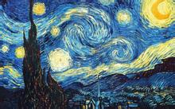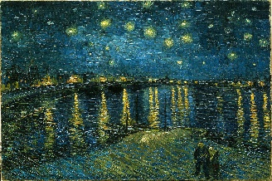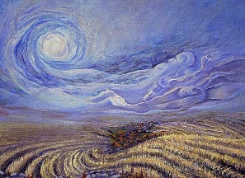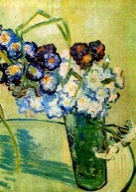
 | (b) | 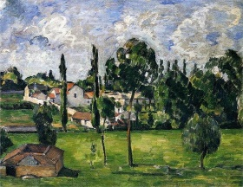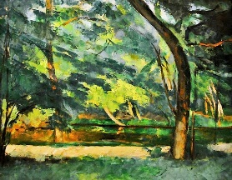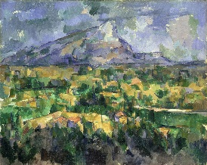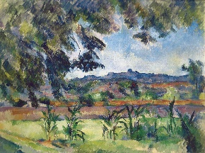
 | (c) | 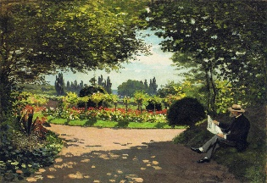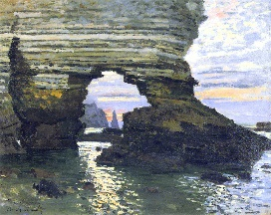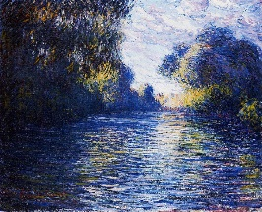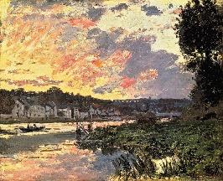
Sad | (a) | 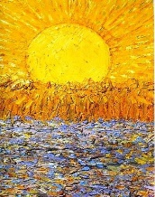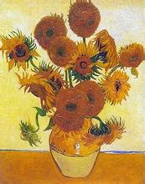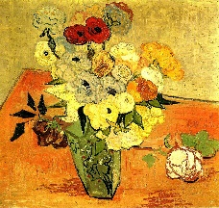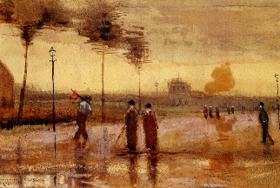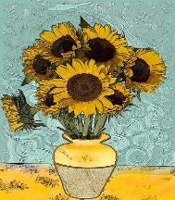
 | (b) | 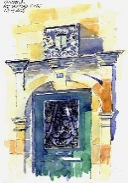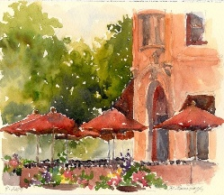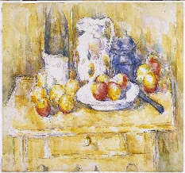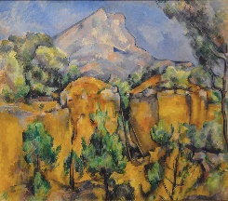
 | (c) | 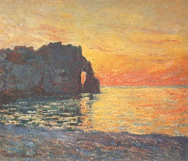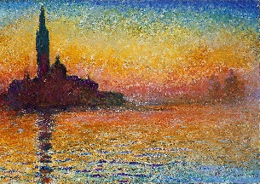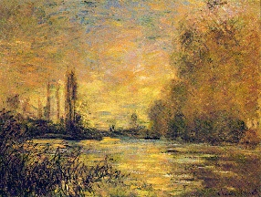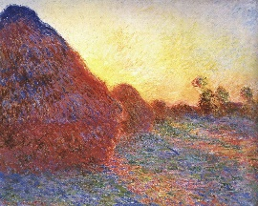
Surprise | (a) | 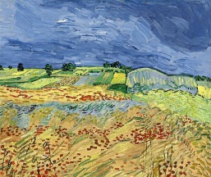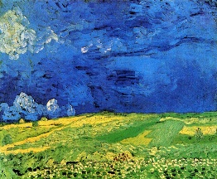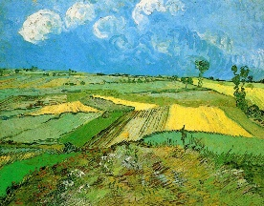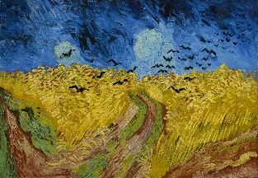
 | (b) | 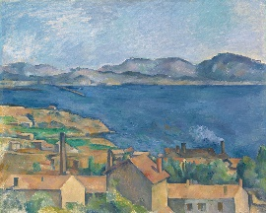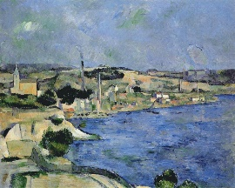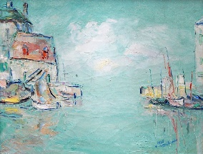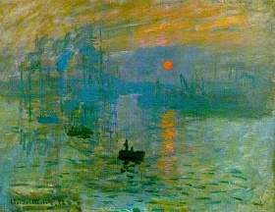
 | (c) | 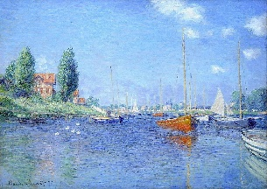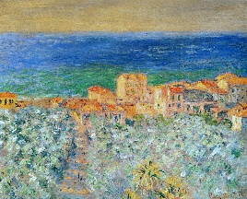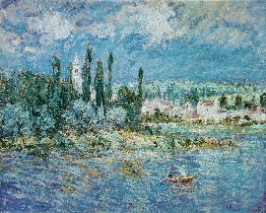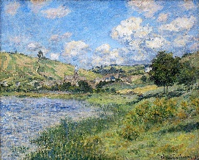
Fig. 6 Example of painting recommendation result. (a) van Gogh, (b) Cézanne and (c) Monet

