Light Therapy System: Combining Real-time Emotion Recognition and Learning-based Color Recommendation

Yaohui Yu, Eunjeong Ko, Jinxi Li and Eun Yi Kim

Visual Information Processing Laboratory, Dept. of Internet and Multimedia Engineering, Konkuk University
1204 New Millennium Building, Konkuk University, 120 Neungdong-ro, Gwangjin-gu, 05029
Seoul, South Korea
{ yuyaohui, rritty33, lijinxi, eykim }@konkuk.ac.kr

Abstract

Recent years, light therapy has been proved to be a promising treatment. Generally light has an important component that influences on sleep and a significant efficacy on the symptoms of cancer, wound healing and infection. In this paper, we propose a novel light therapy system that automatically estimates user’s emotional states from real-time facial expression recognition via a convolutional neural network, then provides color compositions learnt by probabilistic latent semantic analysis and lights to the user via Bluetooth. The proposed system consists of a web camera, emotion predictor, color recommender, light controller, and smart bulb. From the web camera, the emotion predictor estimate user’s facial expression during 10 seconds, and then color recommender suggests the proper colors according to the user’s dominant emotion. Finally, lighting controller sends the signal to the smart bulb via Bluetooth. The color of the bulb is changed by the proposed system. The proposed system can applied to various domains: interior design, psychological counseling and smart home.

Keywords-Light therapy; Emotion recognition; Facial expression recognition; Color recommendation

I. Introduction

Recent years, light therapy has been proved to be a promising treatment for various problems and shown inclusive results [1]. Generally, light has an important component that influences on sleep and a significant efficacy on the symptoms of cancer, wound healing and infection. Therefore, it is essenatial for automatically estimating the user’s emotional states and recommend the appropriate colors and reveal the colors using smart bulbs.
In this paper, we propose a novel light therapy system that automatically estimates user’s emotional states from real-time facial expression recognition, then provides color compositions and lights to the user via Bluetooth. The proposed system consists of a web camera, emotion predictor, color recommender, lighting controller, and smart bulb. From the webcam, the emotion predictor estimate user’s facial expression during 10 seconds, and then color recommender suggests the proper colors according to the user’s dominant emotion. Finally, lighting controller sends color information to the smart bulb. The color of the bulb is changed by the proposed system.
The proposed system can applied to various domains: interior design, psychological counseling and smart home.

II. Prototype of the Proposed System

The goal of the proposed system is to automatically estimate user’s emotional state, and then provide the proper colors of a smart bulb to the user. For this, the proposed system consists of a web camera, emotion predictor, color recommender, light controller, and a smart bulb. Figs. 1 shows the overview of the proposed system.
Given streaming from web camera, the emotion predictor first detects user’s face and then predicts the probability of user’s facial expression via a convolutional neural network. During 10 seconds, the proposed system calculate the dominant emotion among seven emotions such as happy, angry and sadness.
The color recommender recommends the appropriate color according to user’s dominant emotion. It can also provide color compositions that are learnt by probabilistic latent semantic analysis. These are set by user’s preference. The estimated color compositions are transferred by the light controller. The light controller sends the signal to the bulb via Bluetooth. According to the number of installed bulb, the light controller transfer different signals that send one color or composited colors in the predefined palette. Bulb reveals lights to the user. The proposed system can provide therapy to the user and be applied to various domain such as smart phone, mental healthcare, interior designs and etc.
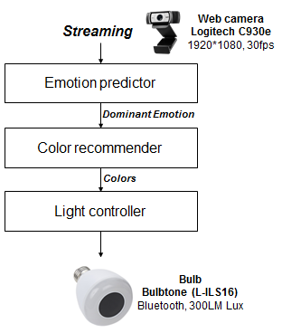
Figure 1. Overview of the proposed system.

II. Emotion Recognizer

This module recognizes user’s facial expression from streaming and estimates their dominant emotion in real-time. Thus, it first detects face region in an input image using Adaboost algorithm and then analyzes facial expression using a convolutional neural network. These results are accumulated during 10 seconds. Finally, it can estimate the dominant emotion of the user.
To represent user’s emotion, various emotional domain is used such as Rushell’s emotions [2], Ekman’s basic emotions [3], Plutchik’s wheel [4] and Kobayashi’s affective words [5]. Among them, we employ Ekman’s basic emotions that consist of three positive emotions and three negative emotions; {anger, disgust, fear, happy, sad, surprise, and neutral}.
In order to analyze facial expression of the user, it first detects face regions from a given image. Face detection has been widely investigated two decades. An efficient object detection approach using cascade classifiers has been proposed by Viola and Jones [6], which is Adaboost algorithm. Adaboost algorithm is a machine learning based approach where a cascade function is trained from a lot of positive and negative images, has been used by many researchers. In this work, Adaboost algorithm is used to detect face candidates in the image. Among the candidates, it localizes the largest one as user’s face. Figure 2 shows results from Adaboost algorithm for face detection. As shown in Figs. 2, it can accurately detect user’s face despite of user’s face rotation.

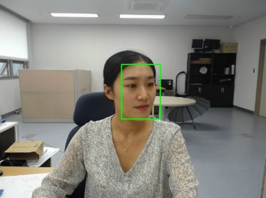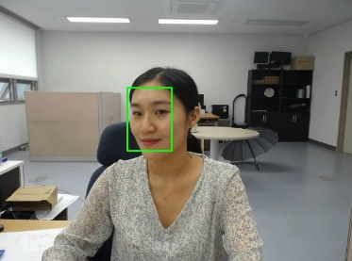
Fig. 2 Examples of face detection results.

In this module, we employ a Convolutional Neural Network that has been used to recognize user’s emotion. Recently, CNN-based approaches have showed comparable performance to human on various classification tasks. Here, we used a trained network [7-8] which fine-tuned pre-trained CaffeNet model using a large face recognition dataset [9], which contains a total of 494,414 face images from 10,575 subjects. In the CaffeNet model, the same layers were used with the original model except for the number of output node at last layer that was set to 7. Figure 4 shows the results of the emotion recognition. Figs. 3(a) indicates face detection results and Figs. 3(b) represent the distribution of the predicted emotions, respectively.
In order to determine user’s dominant emotions, we accumulate the prediction results during 10 seconds. The accumulation time is set by the experiment. During 10 seconds, the most frequent emotion is selected as the dominant emotion. Given the dominant emotion, the proposed system find the proper light colors according to the user’s emotional state and send light controller that can control bulb’s color via Bluetooth.

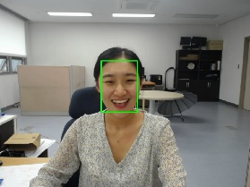 | 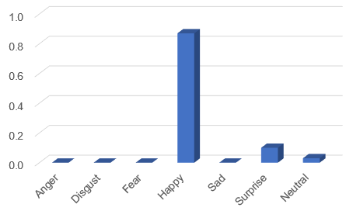
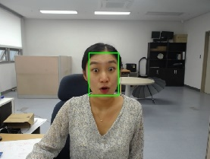 | 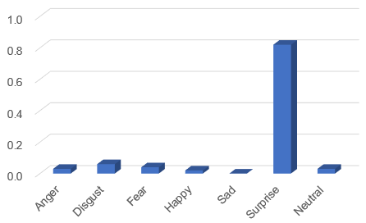
(a) | (b)
Fig 3. Example of emotion recognition results.

III. Color Recommender

Given user’s dominant emotion, the proposed system recommends the proper colors to the user based on conventional color therapy and color compositions learnt by probabilistic latent semantic analysis (pLSA).
The colors based color therapy have been proposed based on [1,5] and widely used in various applications such as interior design, mental healthcare, etc. They provide the appropriate color depending on user’s emotional status. Table 10 shows the used colors defined in color therapy [10-11].
The proposed system extends the color into their combinations to provide various colors to the user related to their emotional state. Thus, we map the conventional color therapy into a different affective model that can be easily applied to other domains.
In order to annotate human affects, several affective models have been defined. Among them, Kobayashi’s affective model has been widely applied to various domain such as web design, textile, fashion, etc [5]. The affective words in the model are composed of {pretty, colorful, dynamic, gorgeous, wild, romantic, natural, graceful, quiet, classic, dandy, majestic, cool, pure, and modern}. The affective words are mapped based on effects from traditional color therapy. The mapped affects are described in Table 1.

Table 1. Kobayashi’s affects mapped from color therapy.
 | Color Effects | Mapped affects
Anger | Broad mind, Liberation | Cool, modern
Disgust | Peace, Stability, Calmness | Cool, natural
Fear | Reinforcement, Bright, Harmony | Pretty, Romantic
Happy | Comfort, Nature, Young | Pure, Romantic
Sadness | Recovery, Bounce, Warm | Dynamic, Gorgeous
Surprise | Stability, Relax, Calmness | Cool, quiet
Neutral | Wisdom, Aesthetic | Natural

Kobayashi et al. have defined manually relations between colors and the affective words through market survey. However, in order to estimate hidden contexts between colors and the affective works, we first collect ground truth data from crawled Photo.Net images, perform user survey to generate the affective labels. Then, we extract color compositions that is group given image into regions similar colors, selects seed regions that locates the center of the image and have large areas among entire regions, and finally combine three colors that one is from one seed region and two its neighbor regions. The extracted color compositions are quantized into the occurrence vector that consists of 592 color compositions. In order to find the relationship between the color compositions and the affects, probabilistic latent semantic analysis is utilized.
To learn the pLSA model [12], a term-document matrix should be computed as a prerequisite. The $n(d_{i}, w_{j})$ means the number of the visual feature $w_{j}$ occurred in the image $d_{i}$. The occurrence vector ($n\left(d_{i}, w_{1}\right), n\left(d_{i}, w_{2}\right), …, n(d_{i}, w_{j})$) of $d_{i}$ is normalized using L₁-norm. Thus, the pLSA model is trained by an expectation maximization (EM) algorithm. We train the pLSA to estimate$P(w_{j}|z_{k})$ the probability of a sentiment given the current image as the scale and$P\left(z_{k} | d_{i}\right)$, the probability of a sentiment given the current image as the ground truth.
E-step: The probabilities of sentiments given the observations $P\left(z_{k}|d_{i}, w_{j}\right)$ are computed from the previous estimate of the model parameters (randomly initialized).
$$P\left(z_{k}|d_{i}, w_{j}\right)∝ \frac{P(z_{k}|d_{i})P\left(w_{j} | z_{k}\right)}{\sum_{z∈Z}{P\left(z_{z} | d_{i}\right)P(w_{j}|z_{z})}}$$
M-step: The parameter $P(w_{j}|z_{k})$ are updated with the new expected values$P\left(z_{k}|d_{i}, w_{j}\right)$.
$$P\left(w_{j} | z_{k}\right)∝ \frac{\sum_{j∈W}{n\left(d_{i}, w_{j}\right)P\left(z_{k}|d_{i}, w_{j}\right)}}{\sum_{j∈W}{\sum_{i∈D}{n\left(d_{i}, w_{j}\right)P\left(z_{k}|d_{i}, w_{j}\right)}}}$$
$$P\left(z_{k} | d_{i}\right)∝ \frac{\sum_{j∈W}{n\left(d_{i}, w_{j}\right)P\left(z_{k}|d_{i}, w_{j}\right)}}{n\left(d_{i}\right)}$$

In this work, the pLSA learning is separately performed, thus two scales are generated for the respective color compositions and SIFT-based features. Figure 4 shows scales generated by pLSA learning, where x-coordinate is the visual features from 592 color compositions and y-coordinate is Kobayashi’s sentiment, respectively. The brighter cells mean that the visual features have the high relationship with the corresponding to the affect.

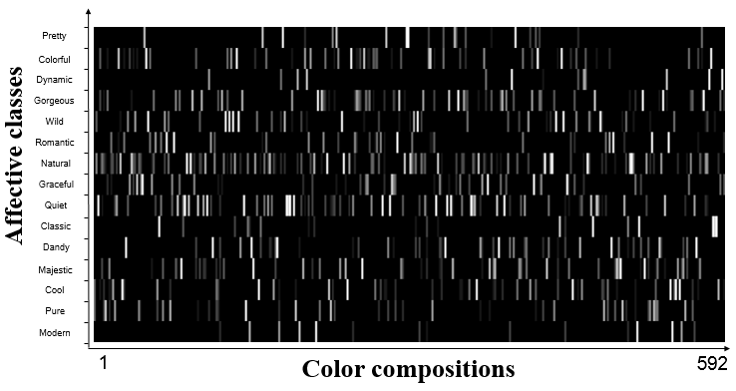
Fig. 4 Correlation between color compositions and Kobayashi’s affects.
The color compositions estimated by the proposed system are shown in Table 2. Top-20 color compositions are extracted by highly correlated in mapped affects. As can be seen in Table 2, color defined in the existing color therapy are included in the color compositions.
Table 2. Used color and color compositions depending on user’s emotional state.
Emotion | Color | Color compositions learnt by pLSA
Anger
Disgust
Fear
Happy
Sad
Surprise
Neutral

IV. Light Controller

The proposed system uses Bluetooth to transfer the color signal for a smartbulb [13]. Similar to a general smart bulb, which is controlled by the palette passed to the predefined colors, a toggle is used to send the color signal to the bulb via Bluetooth. Fig 5 shows the example of controlled bulb by light controller.

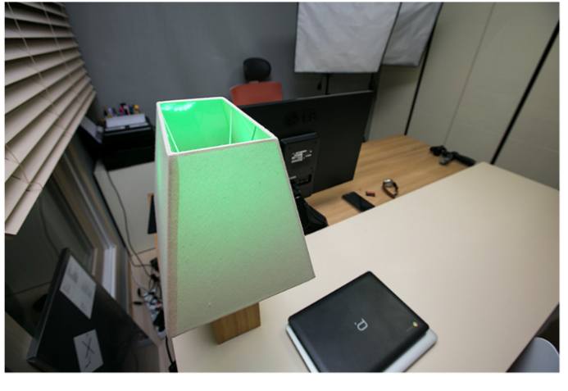
Fig. 5 Example of light control according to user’s state ‘Happy’.

V. Conclusion

In this paper, we proposed a novel light therapy that automatically estimates user’s emotional states from real-time facial expression recognition, then provides color compositions and lights to the user via Bluetooth. The proposed system consists of a web camera, emotion predictor, color recommender, light controller, and smart bulb. From the web camera, the emotion predictor estimate user’s facial expression during 10 seconds, and then color recommender suggests the proper colors according to the user’s dominant emotion. Finally, lighting controller send the signal to the smart bulb via Bluetooth. The color of the bulb is changed by the proposed system. The proposed system can applied to various domains: interior design, psychological counseling and smart home. The proposed system needs some improvements including (1) verification of the generalizability of the proposed system for users as light therapy, and (2) increasing the number of colors that can appear smart bulb.

Acknowledgments

This research was supported by the MSIT(Ministry of Science and ICT), Korea, under the ITRC(Information Technology Research Center) support program(IITP-2017-2016-0-00465) supervised by the IITP(Institute for Information & communications Technology Promotion).

References

[1] A. v. Maanen, A. M. Meijer, v. d. Heijden and F. Oort, “The eff ects of light therapy on sleep problems: a systematic review and meta-analysis.,” Sleep Med Rev 29: pp. 52–62, 2015
[2] J. A. Russell, “Core affect and the psychological construction of emotion,” Psychol. Review, 110, 1, pp. 145–172. , 2003.
[3] J. A. Mikels, B. L. Fredrickson, G. R. Larkin, C. M. Lindberg, S. J. Maglio, and P. A. Reuter-Lorenz, “Emotional category data on images from the international affective picture system,” Behavior Research Methods vol. 37, pp. 626-630, 2005.
[4] R. Plutchik, The nature of emotions. American Scientist 89(4), 344–350, 2001.
[5] S. Kobayashi, Color image scale. Kodansha, JAPAN, 1991.
[6] P. Viola and M. Jones, “Rapid Object Detection using a Boosted Cascade of Simple Features,” In CVPR, 2001.
[7] Y. Jia, E. Shelhamer, J. onahue, S. Karayev, J. Long, R. Girshick, S. Guadarrama and T. Darrell, “Caffe: Convolutional architecture for fast feature embedding,” 2014, arXiv preprint arXiv: 1408.5093.
[8] G. Levi and T. Hassner, “Emotion recognition in the wild via convolutional neural networks and mapped binary patterns,” In Proceedings of the 2015 ACM on International Conference on Multimodal Interaction, 2015, pp. 503-510.
[9] D. Yi, Z. Lei, S. Liao, and S. Z. Li, “Learning face representation from scratch,” 2014, arXiv preprint arXiv: 1411.7923.
[10] B. Kim and D. Kim, “Smart emotional lighting control method using a wheel interface of the smart watch,” 2016, Journal of the Korea Institute of Information and Communication Engineering 20: pp. 1503-1510, 2016.
[11] J. Jung, J. Moon, J. Lim, T. Lim, “The design of a light therapy system using user’s emotion,” 2016, In KICS 2016.
[12] T. Hofmann, “Probabilistic latent semantic indexing,” 22nd Annual Conf. Research and development in information retrieval, pp.50-57, 1999.
[13] www.hyundailivart.co.kr.

